WYE VALLEY & THE FOREST OF DEAN
Friday 27 - Tuesday 31 March 2026

A 3-tier payment plan has been devised to help you, if you need it: For members sharing a room the cost is £540 (£75 non-returnable deposit, £232.50 payable by the 15 November, and final balance of £232.50 payable by 15 January 2026. For those members having a single room £639: (£75 non-returnable deposit, £282 payable by the 15 November, and final balance of £232 payable by 15 January 2026

Visit the beautiful area of the Wye Valley and the Forest of Dean and stay in the Bells Hotel & Country Club, Coleford https://bells-hotel.co.uk/ for 4 nights £540 (+ £99 single supplement).

What is included in the cost:
- 4 nights dinner, bed, breakfast and 2 nights entertainment.
- Excursions include a relaxing 40 minute cruise on the Wye Valley Cruises from Symonds Yat West, and
- Return train journey on Dean Forest Railway from Norchard
- Additional excursions for free time in Monmouth, Tintern Abbey for a photo stop, Chepstow, Hereford, Ross on Wye and Ledbury if you require them.
- Luxury coach travel throughout
- Porterage at the hotel
- Driver’s tip

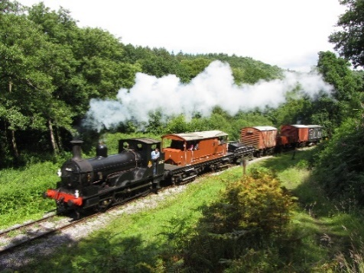
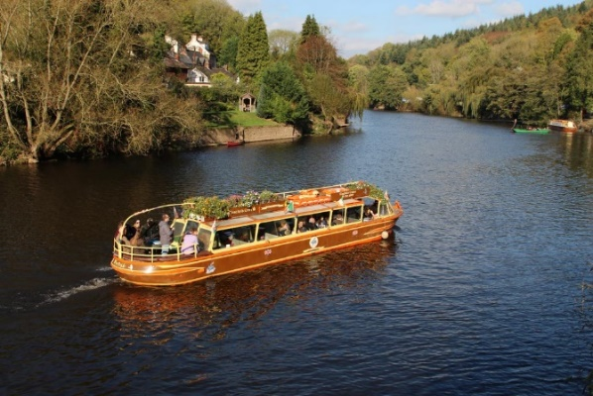

______________________________________________________________________________

WYE VALLEY & FOREST OF DEAN BOOKING FORM

If you are interested, please contact EITHER Linda Grigsby, 37 Albatross Gardens, South Croydon CR2 8QW; Mob: 07754092042 OR Cariss Smith, 62 Penwortham Road, South Croydon CR2 0QS; Mob: 07904 163454, with either cash, cheque payable to Croydon u3a and stamped addressed envelope, or by Bank Transfer account no. 13630003, sort code 23-05-80 YOU MUST PUT THE NAME OF YOUR OUTING AS THE REFERENCE)

Name(s) .......................................................Membership No(s) .................................
Address: ..................... ...................................................Post Code............................
Tel. No. ......................................E-mail ................................................. ..............

I would like …….. tickets for the Wye Valley trip and enclose cash/cheque (with sae) or paying BT

My contact name and telephone details in case of emergency is ………………………………………

CROYDON u3a TRAVEL TEAM EVENT
General Information and Booking terms and conditions

Please carefully read these Booking Terms and Conditions, as submission of a Booking Form will be taken as your acceptance of them. We also request that you carry Identity details with your name. Please also carry a card with your contact in case of emergency, Tel. number and any significant medical conditions. THIS EMERGENCY CONTACT MUST BE LOCATED IN THE UK.

Coach Pick up and Drop off are at Fairfield Halls Bus stop KA. See cover page of poster for times. On the day of an outing, if you have any problems joining the trip, please ring the Trip Organisers (mobile numbers on cover page of poster or on the ticket) by 7:00am. Outings are for Croydon U3A members only. In the event of low take-up, we may take members from other U3As and non-U3A members on an occasional basis.

Booking Forms: Booking forms for each outing are dealt with individually. When booking for multiple trips, a separate booking form and stamped addressed envelope are required for each one. Your booking may be jeopardised if this is not done. If you request more than one place, we must have the first name and surname and U3A number of each person.

Payment: Make payment online to Croydon u3a Business Account No. 13630003 Sort Code 230580 Reference – insert your Surname. Alternatively, pay by cheque. Cheques may be dated for any time between Booking Form submission date and two months before the outing / event date. Please send your completed Booking Form, cheque and self-addressed envelope to the address given on the Booking Form.

Reduced admission: We can only offer the reductions which are advertised by the venue itself at the time we book it. We cannot deal with any special offers or discounts you may personally have.

Refunds: Refunds are generally non-refundable unless we are able to resell the place.

Mobility Requirements: Some, but not all, of our outings are suitable for members with manageable mobility restrictions. You must contact the named Travel Team Trip Organiser member on the poster cover page before booking if you wish to bring a mobility aid so that we can discuss your needs.
We will mention in our publicity and outing details any significant access or safety considerations of which we are aware. YOU MUST BE ABLE TO GET ON AND OFF THE COACH UNAIDED.

Restricted mobility: Members with restricted mobility may be accompanied by a carer on any outing, but a place needs to be booked. The carer does not have to be a U3A member but will be required to pay the full cost. Members are asked to think carefully about the physical demands of the outing and their own situation before submitting an application. We need to ensure that all participants are safe and that everyone enjoys the day. Ultimately the Travel Team reserves the right to decline applications in exceptional situations, regrettable as this may be.

Your responsibilities: You are asked to pay particular attention to the scheduled Arrival & Registration, Visits and Registration & Departure times and assemble at the designated meeting point. If you are late, we may have to leave without you to enable us to keep to the time-table. In such an instance, you would have to arrange your own return home, and you would not be entitled to any refund for the cost of the unused portion of the day. If this should happen, we would endeavour to contact you and/or your emergency name contact number. We ask members for their mobile phone numbers and for them to ensure they are switched on during the outing. Participants are responsible for themselves and their belongings.

Data protection: The details you give us on the booking form will be held by the organisers until the outing has taken place and will be used only for the purpose of the outing. When it has taken place, they will be destroyed. We keep a record of your mobile numbers to save you giving us those details on every outing. Participants are responsible for themselves and their belongings.

General: We try to schedule comfort stops at a convenient time and place, but it is not always easy to do this for a large coach. Apart from the initial outbound departure time, most other times are approximate. We cannot predict traffic hold-ups or bad weather, both of which may affect our arrival and final departure times.

