u3a Outing to Parham House & Gardens
Thursday 21 May 2026
Coach leaves 8:45am from Fairfield Hall, Park Lane, Croydon
Cost of the trip is £45:00 Price includes coach travel, tea/coffee on arrival, drivers tip and entry to Parham House (with guided tour) and Gardens.
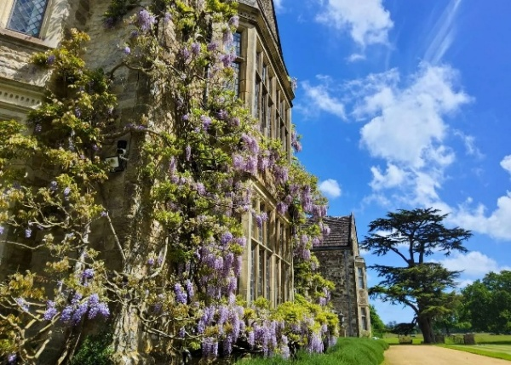
Parham is a traditional stone E-shaped Elizabethan mansion, built in 1557. Idyllically set in the heart of an ancient deer park, below the South Downs. The Elizabethan house contains an important collection of needlework, paintings and furniture. Parham has always been a well-loved family home, and only three families have lived here since its foundation stone was laid.
Complete with a Great Hall and spectacular Long Gallery which is the third longest in England, Parham’s tranquillity and timeless beauty have changed little over the centuries. The gardens include a four-acre Walled Garden with stunning herbaceous borders and Pleasure Grounds.
PLEASE NOTE: There isn’t a lift at this historic house so access to the floors is by stairs.
Return the booking form below to: David Apps, 13 Church Way, South Croydon, CR2 0JT. Tel. 020 8651 0347, with a stamped addressed envelope. If you have problems on the day of outing, ring David 07802 769047 or email: dapps97090@aol.com. At other times please use David’s landline 0208 651 0347
Please read Travel Team’s Terms and Conditions.
...............................................................................................................................

BOOKING FORM – Parham House and Gardens

Coach leaves at 8:45 am Thursday 21 May 2026. Price: £45:00
u3a Member/s - Name(s) .......................................................Membership No(s) …………
Address ..................................................................................Postcode..................
Mob No. ...........................................E-mail ...................................................................
I would like ...... ticket(s). Total £ …… Cheque payable to “Croydon u3a” (enclose a sae) OR: by bank transfer. Acct No: 13630003. Sort Code 23-05-80. Please put “Parham” as the reference
My contact in case of emergency is (not someone who is also on the coach trip):

Name…………....................................................Tel. No………………………………

